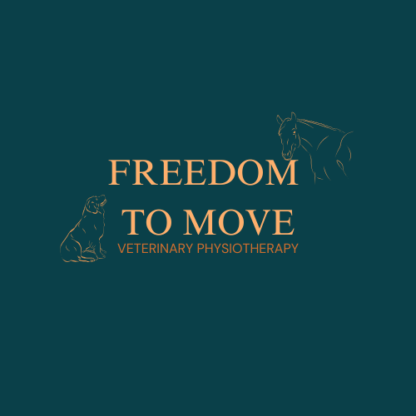
Tegan Burnard
BSc (hons), RAMP reg, MIRVAP
07842831575
info@freedomtomovevetphysio.com

Veterinary Consent Form

Client Details
Title |  |  | Full name
Address
Mobile no. |  |  |  | Email address
Patient Details
Name |  |  |  |  | Breed |  |  | Age
Colour |  |  |  |  | Gender |  |  | Castrated/spayed?

To be completed by Veterinary Practice
Practice name
Practice Address
Referring Veterinary surgeon
Presenting condition, summary, areas of concern etc.
Is the patient currently on any medication?
Other medical issues

Please return this form by email to EMAIL
I give consent for this animal to receive physiotherapy treatment, declaring to the best of my knowledge that there is no medical reason why this animal cannot undergo physiotherapy assessment and relevant treatment (may include electrotherapies).
Referring vet
Signed |  | Date
Do you require a written report following treatment?

